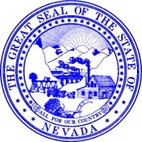

ALAN JENNE

*Director*

JORDAN GOSHERT

*Deputy Director*

MICHAEL SCOTT

*Deputy Director*

STATE OF NEVADA

**DEPARTMENT OF WILDLIFE**

6980 Sierra Center Parkway, Suite 120

Reno, Nevada 89511

Phone (775) 688-1500 • Fax (775) 688-1595

JOE LOMBARDO

*Governor*

July 16, 2025

Re: NDOW needs your help.

Dear Taxidermist or Meat Processor:

The Nevada Department of Wildlife (NDOW) requests your assistance in conducting surveillance for disease in hunter-harvested: **Bighorn sheep, Mule Deer, and Elk**

**This year, NDOW has implemented mandatory CWD testing for all deer harvested in the Transport Restriction Zone (TRZ). The TRZ comprises hunt areas 19, 20, 21, and 29. These units will have the same restrictions as the out-of-state transport restrictions (Senate Bill 85). If you receive an animal from one of these hunt units, please take the sample or call your local NDOW office to have the sample taken. You can find more information about the Transport Restriction Zone by going to ndow.org, search CWD and then scroll down to the CWD Transport Restriction Zone Guidelines document. Please contact NDOW if you have any questions.**

Bighorn sheep samples are for nasal sinus tumor (see attached graphic). Deer and elk will be screened for chronic wasting disease (CWD). We request the remainder of the skull be frozen after the removal of horns/antlers. If you have experience collecting CWD samples for deer and elk, please do so.

To incentivize collecting disease surveillance information from hunter-harvested animals, NDOW is offering taxidermists and meat processors $10.00 for each collected head that meets the specific criteria outlined on the reverse page entitled, “Criteria for Head Collection”.

If you are interested in participating in this incentive program, please return a completed vendor form with a voided check OR your banking information written on letterhead to LuAnn Veinneau, 6980 Sierra Center Parkway, Suite 120, Reno, NV 89512. This form allows you to become a vendor for the State of Nevada. You can also complete the Vendor Registration Form online at [www.controller.nv.gov](http://www.controller.nv.gov/) by selecting Electronic Vendor Registration. Contact LuAnn at (775) 688-1573 with any accounting questions. Payment will be made upon receipt of an invoice. If you have an existing contract with NDOW, payments will accrue in accordance with your contract.

The collection of bighorn sheep samples is limited to 50. There is no limit for CWD samples. Rotted or very desiccated heads will not be compensated for. Contact Chris Morris (775) 842-7970 or Nate LaHue (nate.lahue@ndow.org) with questions regarding the collection process or when you would like NDOW to retrieve the frozen heads.

Thank you for your help in assisting us with this important wildlife health disease screening effort.

Sincerely,

______________________

Nate LaHue, DVM, MPVM

Wildlife Health Specialist- Veterinarian

Game Division  
 Nevada Department of Wildlife

[Nate.lahue@ndow.org](mailto:Nate.lahue@ndow.org)

775-688-1813

**Criteria for Head Collections for Bighorn Sheep, Mule Deer and Elk**

For bighorn sheep we are interested in either sex and all ages as we are screening for bacteria that cause pneumonia and the presence of sinus tumor

## Bighorn Sheep

Please save bighorn sheep heads of either sex harvested anywhere in Nevada. You can save them in a freezer and contact Chris Morris (contact below) for pick up.

In an effort to improve surveillance sampling efficiency we are targeting 2‐year‐old and up bucks

and bulls, as these animals have been found to have the highest incidence of CWD.

## Mule Deer

Please save heads from bucks 2 years or older from ALL Nevada hunt units, as well as all Deer from within the TRZ (Areas 19, 20, 21, and 29).

## Elk

### Please save heads elk of both sexes that are 2 years and older from ALL applicable Nevada hunt units.

Please contact Chris Morris at [crmorris@ndow.org](mailto:crmorris@ndow.org) or (775) 842‐7970 to receive tags for recording hunter information that can be attached to the bag holding the head or for supplies and protocol if you wish to collect the CWD sample yourself.

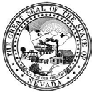**STATE OF NEVADA**

# VENDOR REGISTRATION

**STATE CONTROLLER’S OFFICE** 555 E WASHINGTON AVE STE 4300 LAS VEGAS NV 89101-1071

**PHONE: 702/486-3810 or 702/486-3856**

***All sections are mandatory and require completion. IRS Form W-9 will not be accepted in lieu of this form.***

1. **NAME** For proprietorship, provide proprietor’s name in first box and DBA in second box.

Doing Business As (DBA)

Legal Business Name, Proprietor’s Name or Individual’s Name

1. **ADDRESS/CONTACT INFORMATION**

|  |  |  |  |  |  |
| --- | --- | --- | --- | --- | --- |
| Address A – Physical address of  Company Headquarters Individual’s Residence  Is this a US Post Office deliverable address? Yes No | | | Address B  Additional Remittance – PO Box, Lockbox or another physical location. | | |
| Address | | | Address | | |
| Address | | | Address | | |
| City | State | Zip Code | City | State | Zip Code |
| E-mail Address | | | E-mail Address | | |
| Phone Number | Fax Number | | Phone Number | Fax Number | |
| Primary Contact | | | Primary Contact | | |

1. **ORGANIZATION TYPE AND TAX IDENTIFICATION NUMBER (TIN)** Check only **ONE** organization type and supply the applicable Social Security Number (SSN) or Employee Identification Number (EIN). **For proprietorship, provide SSN or EIN, not both.**

|  |  |  |
| --- | --- | --- |
| Individual **(SSN)**  Sole Proprietorship **(SSN or EIN)**  Partnership **(EIN)** Corporation **(EIN)** Government **(EIN)**  Tax Exempt/Nonprofit **(EIN)**  Trust/estate **(SSN or EIN)** | **LLC** tax classification:  Disregarded Entity Partnership Corporation | **SSN**  Name associated with SSN: |
| **EIN** |
| New TIN? No Yes – Provide previous TIN & effective date.  Previous TIN: Date: |

**OTHER INFORMATION** Check **all** that apply.

|  |  |  |  |  |  |  |  |  |
| --- | --- | --- | --- | --- | --- | --- | --- | --- |
| Doctor or Medical Facility | | |  |  | In-State (Nevada) |  |  | NV Business ID#(ex:NV12345678910) |
|  |  | Attorney or Legal Facility |  | DBE Certificate #: |  | | |

1. **ELECTRONIC FUNDS TRANSFER *Per NRS 227, payment to all payees of the State of Nevada will be electronic.***

Complete section **AND** provide a copy of a voided imprinted check for the account. If there are no checks for the account, savings or prepaid card, a signed letter restating the information must be provided(Companies must use company letterhead) **Deposit slip or WIRE information will not be accepted.** Information on this form and the supporting documentation must match. Allow 10 working days for activation.

|  |  |  |  |
| --- | --- | --- | --- |
| The information is for address A B Both | | | |
| Bank Name | | Bank Account Type Checking Savings | Provide **ONE** e-mail address for receiving payment notification |
| Transit Routing Number | Bank Account Number | |

1. **IRS FORM W-9 CERTIFICATION AND SIGNATURE**

|  |  |  |
| --- | --- | --- |
| Under penalties of perjury, I certify that:   1. The number shown on this form is my correct taxpayer identification number (or I am waiting for a number to be issued to me), **and** 2. I am not subject to backup withholding because: **(a)** I am exempt from backup withholding, or **(b)** I have not been notified by the Internal Revenue Service (IRS) that I am subject to backup withholding as a result of a failure to report all interest or dividends, or **(c)** the IRS has notified me that I am no longer subject to backup withholding, **and** 3. I am a U.S. citizen or other U.S. person (as defined by IRS Form W-9 rev August 2013).   Cross out item 2 above if you have been notified by the IRS that you are currently subject to backup withholding because you have failed to report all interest and dividends on your tax return. | | |
| **The Internal Revenue Service does not require your consent to any provision of this document other than the certifications required to avoid backup withholding.** | | |
| Signature | Print Name & Title of Person Signing Form | Date |

|  |  |
| --- | --- |
| **FOR STATE CONTROLLER’S OFFICE USE ONLY**  Primary 1099 Vendor 1099 Indicator Yes No | **Name of State agency contact & phone number:** |
| Entered By Date Comments | |

KTLVEN-01 Rev 06/16

# Registration Instructions

1. **This Registration form is for the use of United States entities only. Non-US entities must submit a Foreign Vendor Registration & IRS Form W-8.**
2. Type or **legibly** print all information except for signature.
3. All sections are mandatory and require completion.

**Specific Information:**

#### NAME

* 1. Partnership, Corporation, Government or Nonprofit – Enter legal business name as registered with the Internal Revenue Service (IRS) in first box. If the company operates under another name, provide it in the second box.
  2. Proprietorship – Enter the proprietor’s name in the first box and the business name (DBA) in the second box.
  3. Individual – Name must be as registered with the Social Security Administration (SSA) for the Social Security number (SSN) listed in Section 3.

#### ADDRESS/CONTACT INFORMATION

* 1. Address A – *If the address is non-deliverable by the United States Postal Service, complete both Address A and B sections.*

Company – Provide physical location of company headquarters. Individual – Provide physical location of residence.

E-mail – Provide a valid e-mail address. Telephone Number – Include area code. Fax Number – Include area code.

Primary Contact – Person (and phone number or extension) to be contacted for payment-related questions or issues.

* 1. Address B – Provide additional remittance address and related information when appropriate.

#### ORGANIZATION TYPE AND TAX IDENTIFICATION NUMBER (TIN OR EIN)

* 1. Individual – A person that has no association with a business.
  2. Proprietorship – A business owned by one person.
  3. Partnership – A business with more than one owner and not a corporation.
  4. Corporation – A business that may have many owners with each owner liable only for the amount of his investment in the business.
  5. LLC – Limited Liability Company. ***Must mark appropriate classification – disregarded entity, partnership or corporation.***
  6. Government – The federal government, a state or local government, or instrumentality, agency, or subdivision thereof.
  7. Tax Exempt/Nonprofit – Organization exempt from federal income tax under section 501(a) or 501(c)(3) of the Internal Revenue Code.
  8. Doctor or Medical Facility – Person or facility related to practice of medicine.
  9. Attorney or Legal Facility – Person or facility related to practice of law.
  10. In-state – Nevada entity.
  11. Disadvantaged Business Enterprise (DBE) – A small business enterprise that is at least 51% owned and controlled by one or more socially and economically disadvantaged individuals. ***Provide certification number.*** See [http://www.nevadadbe.com](http://www.nevadadbe.com/)

for certification information.

* 1. NV Business ID number issued by NV Secretary of State (ex: NV20110123456) .
  2. The Taxpayer Identification Number (TIN) is always a 9 -digit number. It will be a Social Security Number (SSN) assigned to an individual by the SSA or an Employer Identification Number (EIN) assigned to a business or other entity by the IRS. ***Per the IRS, use the owner’s social security number for a proprietorship.***

#### ELECTRONIC FUNDS TRANSFER

Per NRS 227, payment to all payees of the State of Nevada will be electronic. Provide a copy of a voided imprinted check or restate bank information on signed letterhead. ***Deposit slip or wire information will not be accepted.*** All information on this form and the supporting documentation **must match**.

* 1. Bank Name – The name of the bank where account is held.
  2. Bank Account Type – Indicate whether the account is checking or savings.
  3. Transit Routing Number – Enter the 9-digit Transit Routing Number for automatic/direct deposit or ACH.
  4. Bank Account Number – Enter bank account number including 0’s if any.
  5. Direct Deposit Remittance Advice – payment information is sent via e-mail. Companies should provide an e-mail address that will not change. Example: [accounting@business.com.](mailto:accounting@business.com)

#### IRS FORM W-9 CERTIFICATION AND SIGNATURE

* 1. The Certification is copied from IRS Form W-9 (rev. August 2013). See IRS Form W-9 for further information.
  2. The Signature should be provided by the individual, owner, officer, legal representative or other authorized person of the entity listed on the form.
  3. Print the name and title, when applicable, of the person signing the form.
  4. Enter the date the form was signed. Forms over 60 days old will not be processed. **Do not complete any remaining areas. They are for State of Nevada use only.** Mail signed form to:

NEVADA STATE CONTROLLER’S OFFICE 555 E WASHINGTON AVE STE 4300

LAS VEGAS NV 89101-1071

For questions contact 702/486-3810 or 702/486-3856 or [**vendordesk@controller.state.nv.us**](mailto:vendordesk@controller.state.nv.us)

# Sinus Tumors of Bighorn Sheep What is this disease?

* Tumors grow from the lining of the

sinuses in the:

* + Forehead
  + Horns
  + And above the teeth
* Tumors typically cannot be seen from the outside of the head
* Destroys bone, produces thickened sinus lining, gelatinous tissue, mucus and pus
* Unknown cause, but likely an infectious disease that is spread between sheep
* Found in all 3 subspecies of bighorn sheep and in herds from at least 6 states, including Nevada
* No known human health risk

# Why is this disease important?

* Can cause skull and horn Deformities
* Impairs respiratory function and may contribute to chronic respiratory disease that threatens bighorn herds.

In the forehead – note loss of bone structure & gelatinous tissue & thick membrane:

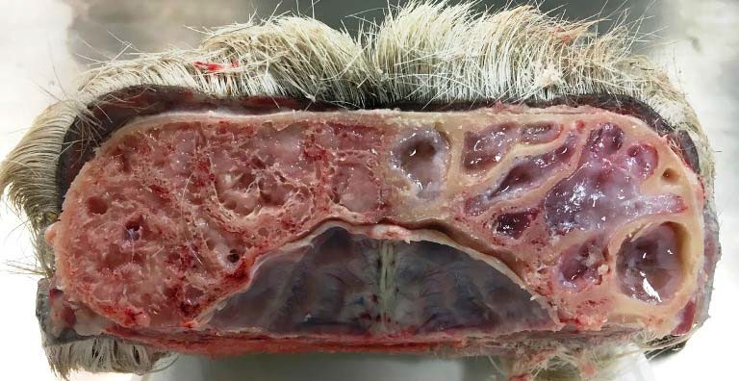

In the horns – note solid bone:

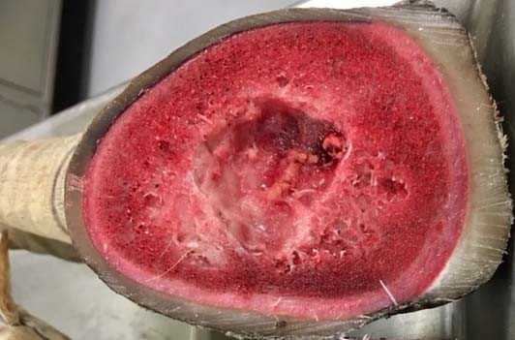

Above the teeth – note mucous and thick membrane:

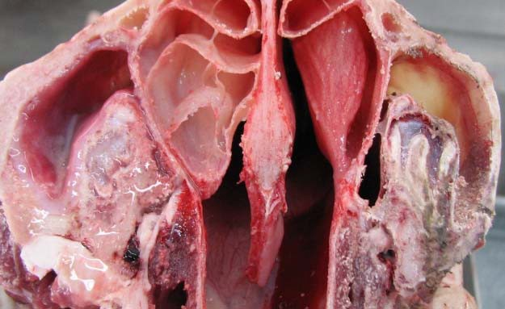

# How can you help?

**Ewe Hunters:** Donate your ewe skull for research if you are not doing a mount. Leave the head when you check in your ewe. If you are doing a mount, ask your taxidermist to please freeze the portion of the head that they would normally throw away.

**Ram Hunters:** Ask your taxidermist to please freeze the portion of the head that they would normally throw away.

Sample collection does **not**

interfere with taxidermy.

Samples will be used to search for the cause of this new disease and to determine how many herds in Nevada may be infected. We will also screen heads for other respiratory pathogens.

# Thank you

**for your participation in this important research!**

For more information contact: Dr. Nate LaHue (831) 428-2321

[nate.lahue@ndow.org](mailto:nate.lahue@ndow.org) Chris Morris

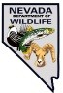(775) 842-7970